

ROS KNIME Logic Docket

1 © 2025 TalenciaGlobal



ROS – Solution Design Docket

Table of Contents
1 ROS – Solution Design Docket 3
2 Introduction to ROS 4
I. ROS Introduction 4
II. Key Goals: 5



ROS – Solution Design Docket

Team Name : Data Mavericks
Scrum Master Name : M.V.S.Harshith

Sl No. | Name | Email
1. | Challa Niharika | nc3955@srmist.edu.in
2. | Sanjana Jaiswal | sj9983@srmist.edu.in
3. | M.V.S.Harshith | vm2620@srmist.edu.in
4. | M.G.Varshini | vm6368@srmist.edu.in
5. | K.Partha Sarathi | pk6526@srmist.edu.in
6.



Introduction to ROS

ROS Introduction
Navigating the fast-paced environment of a modern restaurant usually means dealing with a chaotic, unstructured flow of daily transactions, delivery receipts, and staff schedules. The Restaurant One Solution (ROS) was developed to eliminate this friction. Rather than relying on disconnected spreadsheets and manual data entry, ROS acts as a central digital nervous system. It introduces a fully automated, end-to-end data engineering pipeline that captures and organizes every aspect of a restaurant’s operational lifecycle.
By consolidating critical daily operations into a single platform, ROS takes the guesswork out of business management. It autonomously handles everything from sales and expense tracking to cash management and delivery partner reconciliation. This level of automation directly tackles one of the hospitality industry's most time-consuming headaches: end-of-day financial discrepancies. With the system instantly cross-checking ledgers and matching transactions, management can step away from administrative paperwork and focus entirely on business strategy and growth.
This seamless automation is powered by a specialized, four-tier technology stack:
- Microsoft Excel: Serves as the initial proving ground for data documentation, early anomaly detection, and raw data preparation.
- MySQL: Acts as the secure, structured data vault, utilizing a highly normalized relational database to store and organize the cleaned restaurant records.
- KNIME Analytics Platform: Operates as the "brain" of the pipeline, automatically executing complex data transformations, enforcing validation rules, and running the daily reconciliation workflows.
- Power BI: Translates the processed data into clear, interactive business intelligence dashboards, giving executives real-time oversight of key performance indicators.
Ultimately, ROS is designed to turn isolated, raw numbers into a clear roadmap for success. By bridging the gap between secure database storage, automated workflow processing, and high-level visual analytics, it equips restaurant owners with a reliable, error-free foundation for maximizing profitability and elevating the customer experience

Key Goals:

- Customer places order with a restaurant
- Delivery Partners deliver the order to the customer
- CashUp is published to the finance team
- Cashup amount is banked by the designated employee
- Clients purchase subscription with ROS

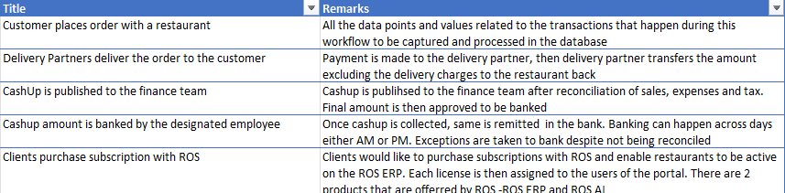


- Customer places order with a restaurant
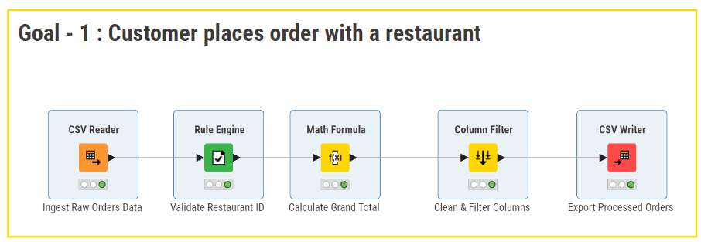
Math Formula Used :
$food_amount$ + $drinks_amount$ + $other_payment$ + $service_charges$ + $delivery_charges$ + $tax_amount$
Rule Engine :
MISSING $restaurant_id$ => "Invalid"
TRUE => "Valid"

- Delivery Partners deliver the order to the customer
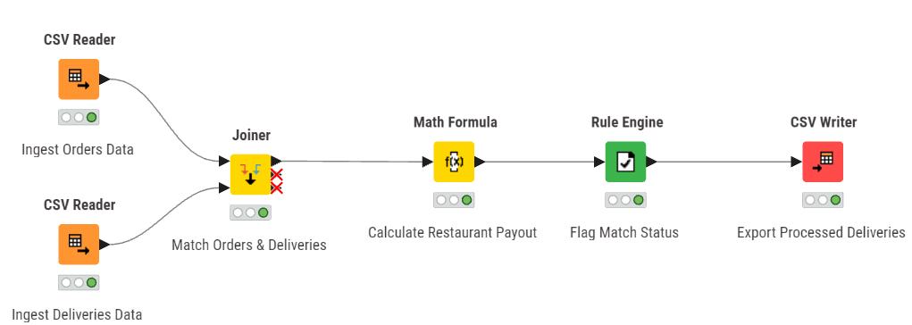
Math Formula Used :
$order_amount$ - $api_amount$
Rule Engine :
$match_status$ = 1 => "Matched"
TRUE => "Unmatched"
Joiner Node :
Criterion 1: restaurant_id (Left) = restaurant_id (Right)
Criterion 2: order_date (Left) = delivery_date (Right)

- CashUp is published to the finance team
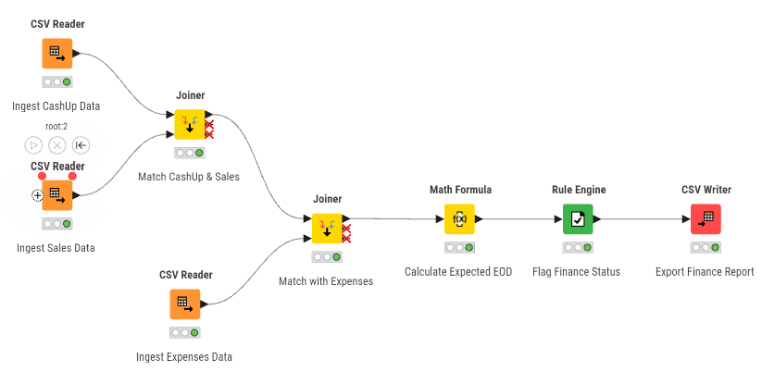
Math Formula Used :
$bod_amount$ + $sales$ - $expenses$ - $tax$ - $delivery_charges$
Rule Engine :
$match_status$ = 1 => "Reconciled"
TRUE => "Mismatch"
Joiner Node - 1 :
Criterion 1: restaurant_id (Left) = restaurant_id (Right)
Criterion 2: cash_up_date (Left) = Date (Right)
Joiner Node - 2 :
Criterion 1: restaurant_id (Left) = restaurant_id (Right)
Criterion 2: cash_up_date (Left) = Exp Date (Right)

- Cashup amount is banked by the designated employee

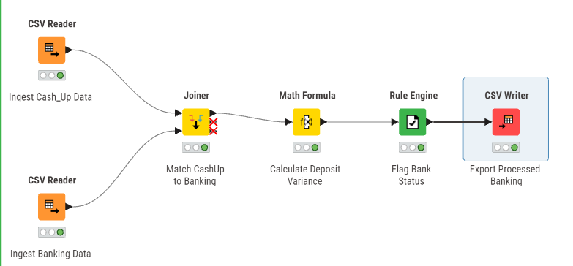

Math Formula Used :
$banked_total$ - $eod_amount$
Rule Engine :
$match_status$ = 0 => "Exception (Unreconciled)"
$match_status$ = 1 => "Banked & Reconciled"
Joiner Node :
Criterion 1: restaurant_id (Left) = restaurant_id (Right)
Criterion 2: cash_up_date (Left) = date (Right)

- Clients purchase subscription with ROS

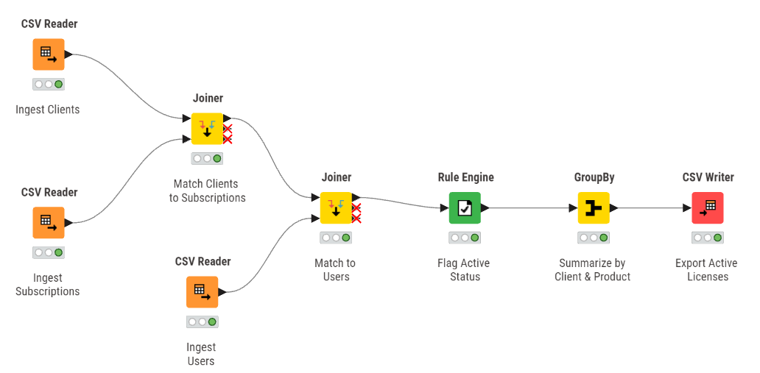 Rule Engine :
$subscription_active$ = 1 => "Active"
TRUE => "Inactive"
Joiner 1 :
subscription_id (Left) = subscription_id (Right)
Joiner 2 :
client_id (Left) = client_id (Right)
Group By :
client_name, subscription_name, product_code

